Project Design Phase
Solution Architecture

Date | 15 February 2025
Team ID | [Enter Team ID]
Project Name | Auto Ticket Classification Using Flow Designer
Maximum Marks | 4 Marks

Solution Architecture:
The solution follows a simple event-driven automation architecture within ServiceNow. When a ticket is created, a Flow Designer workflow is triggered automatically, evaluates the ticket against a set of classification conditions, updates the incident record, and notifies the relevant team - removing the need for manual first-line triage.

1. Architecture Overview
Architecture Flow:
User
-> Creates Incident / Ticket
-> ServiceNow Incident Table
-> Flow Designer Trigger
-> Classification Conditions
-> Update Incident Record
-> Notification
-> Support Team
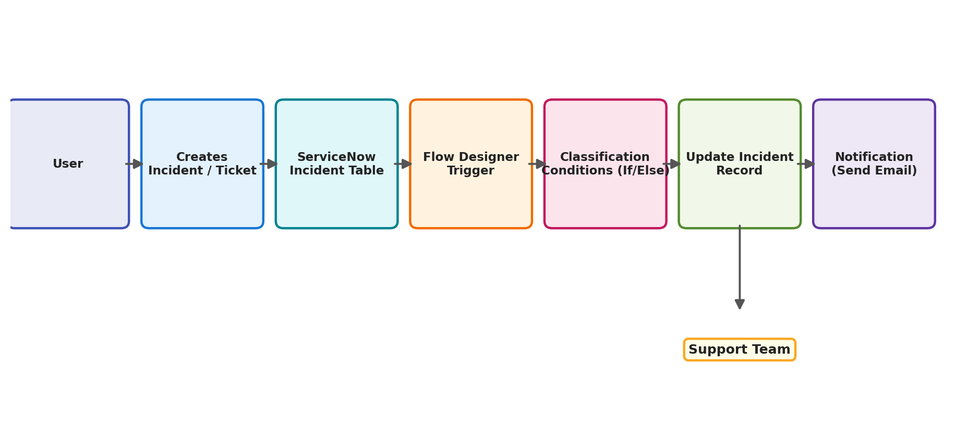
Figure 1: Architecture and data flow of the auto ticket classification solution

2. Main Components
Component | Role
ServiceNow Incident Table | Stores the ticket information entered by the user (number, caller, category, subcategory, short description, description, state, assigned group, assigned to).
Custom Incident Workflow Table | Supports tracking of workflow-specific data used alongside the standard incident record.
Flow Designer | Hosts the automation: trigger, conditions, and actions that classify each ticket.
Flow Logic / If–Else Conditions | Evaluates ticket details against the classification rules and branches accordingly.
Update Record Action | Writes the determined category, subcategory, assignment group and state back to the incident.
Send Email Action | Notifies the relevant user or support team once classification is complete.
Update Set | Captures and tracks all configuration changes so they can be moved between ServiceNow instances.

3. Conditional Logic
The Flow contains multiple If / Else-If branches. Each condition identifies the type of ticket and updates the incident accordingly:
IF issue is Wi-Fi or Network
-> Update Record (Category: Network)

ELSE IF issue is Projector or Hardware
-> Update Record (Category: Hardware)

ELSE IF issue is Forgotten Password
-> Update Record (Category: Access / Password)

ELSE IF issue is Performance
-> Update Record (Category: Performance)

ELSE
-> Update Record (Category: General IT Support)
Trigger: Incident record created.

4. Update Record & Notification Actions

4.1 Update Record Action
After a condition is satisfied, the Update Record action modifies the incident record. Fields updated typically include:
• Category
• Subcategory
• Assignment Group
• Assigned To
• State

4.2 Send Email Action
After classification, the Flow uses the Send Email action to notify the relevant user or support team. The notification can contain:
• Ticket number
• Ticket description
• Classified category
• Assigned group
• Current state

5. Flow Execution
ServiceNow starts the Flow automatically when a ticket is created. Execution can be monitored through Flow Designer's execution details, which help verify:
• Whether the trigger executed.
• Which condition was evaluated.
• Which action was executed.
• Whether the record was updated.
• Whether the notification was completed.
• Whether any errors occurred.

6. Testing
The Flow should be tested using different ticket scenarios:
Test Case | Expected Result
Wi-Fi problem | Network classification
Projector not working | Hardware classification
Forgot password | Password / Access classification
Slow system | Performance classification
Other IT issue | General IT classification

After each test, the incident record and Flow execution details should be checked.

7. Conclusion
The Auto Ticket Classification Using Flow Designer project demonstrates how ServiceNow can automate a repetitive IT support process. By triggering a Flow when a ticket is created and applying predefined classification conditions, the system can automatically process and update tickets. The solution provides a simple foundation that can later be extended with automatic assignment, priority management, SLA automation, notifications, and AI-based classification.

